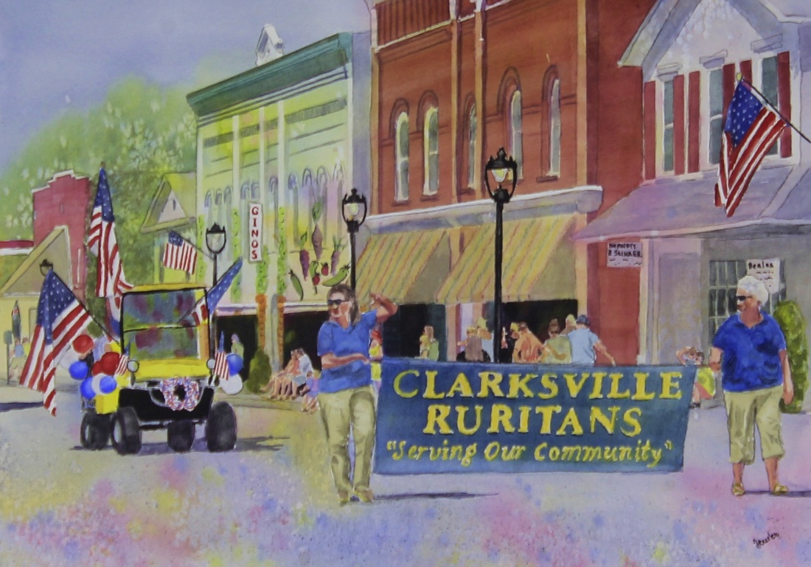
Entry Application
July 4^{th,} 2025 Parade

Clarksville, Virginia

Sponsored by Clarksville Ruritans

All entries must be decorated with a Patriotic Theme & comply
with parade rules & regulations.

Entries should be received by July 3rd. The parade committee reserves the right to reject any entries for any reason before and during the parade. No candy may be thrown from your entry for safety reasons, but individuals may walk along and hand out candy or favors.

Drivers of all motorized vehicles must have a valid driver’s license and must obey all traffic and safety laws. Unnecessary revving of engines or sirens is not allowed. No performance may halt the parade except for Bands. Please be lined up by 10:30 am. Lineup instructions will be published in newspapers the week before the parade.

Sponsors of horse entries must exit on North 3rd Street and clear the parade area immediately after completing the parade route. If you have questions, please call Parade Committee, 738-8250.
__________________________________________________________

Complete & return this parade Clarksville Lake Country Chamber of Commerce

Application by July 3rd to: PO Box 1017, Clarksville, VA 23927

Fax 434-374-8174

Type of Parade Entry

Walking _____ Float _____ Band _____ Bike _____ Emergency vehicle________

Antique Vehicle _____ Golf Cart ____ Other_______ Horses (no.) __________________

Name of Entry ___________________________________________

Responsible person__________________________________

Address____________________ City _______________________ State______ Zip___________

Telephone____________________ Email______________________________

THANK YOU
